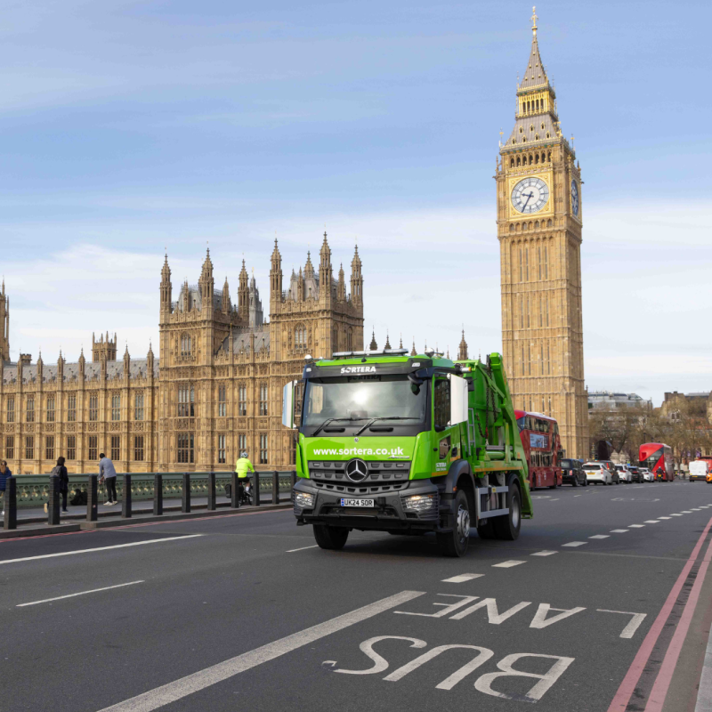

SORTERA LTD
Waste Management Performance
Annual Report
January 2025- December 2025

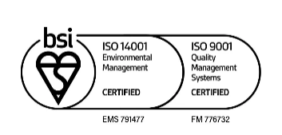

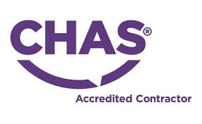


Foreword
Sortera was founded in 2006 and has grown to be one of London’s largest specialist construction waste companies. Every day, our people work with thousands of customers to support positive outcomes for both the environment and wider society.
We provide waste management and recycling solutions for the construction, infrastructure and industrial sectors, focusing on converting residual materials into valuable resources through reuse, recycling and energy recovery.
At Sortera, we are committed to making a positive contribution to the environment and to the communities in which we operate.
As a specialist in construction materials, we work to transform waste into valuable resources through reuse, recycling and energy recovery. By applying a sustainable and practical approach, we help reduce the environmental footprint of the construction sector and support more circular material flows across the industry.
Sortera plays an active role in the transition towards a more circular economy.
Circular material flows – waste as a resource
At Sortera, we view waste as a resource. Our focus is on creating clean and circular material flows by increasing the proportion of materials that can be reused or recycled.
Our ambition is to contribute to the transition to a more circular economy by reducing our own climate impact and supporting our customers in reducing theirs. We aim to be a long-term, knowledgeable and reliable partner throughout this transition.
Profitable growth and expansion into new markets
Sortera’s strategy is centred on sustainable growth and on strengthening our position as a leading provider of circular solutions in Northern Europe. Expansion, including growth through acquisitions, is an important part of this strategy. Since 2006, we have completed more than 20 acquisitions, enabling us to expand geographically and broaden our service offering to customers.
Sortera in numbers
Sortera employs approximately 1,000 people across three markets and has a turnover of SEK 3.6 billion. We operate in Sweden, Finland and the UK, where we are the leading provider of construction waste collection and recycling services in London.

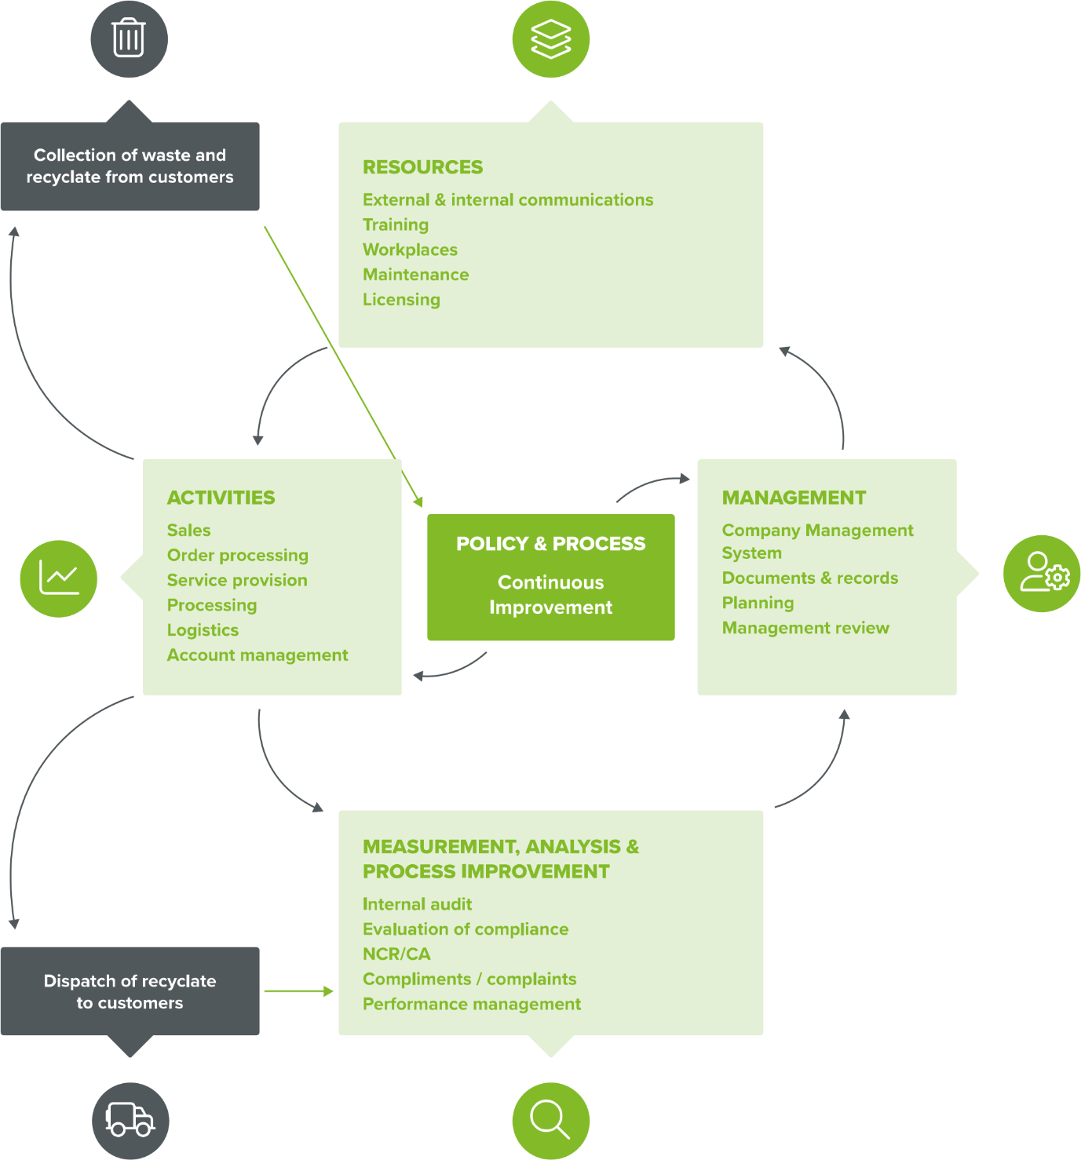
KEY:
process routes customer feedback

Contents
- Scope of operations
- Client Relationships
- Impacts and Risks
- Operational Management
- Corrective, Preventative and Improvement action
- Competence
- Performance Review

- Scope Of Operations
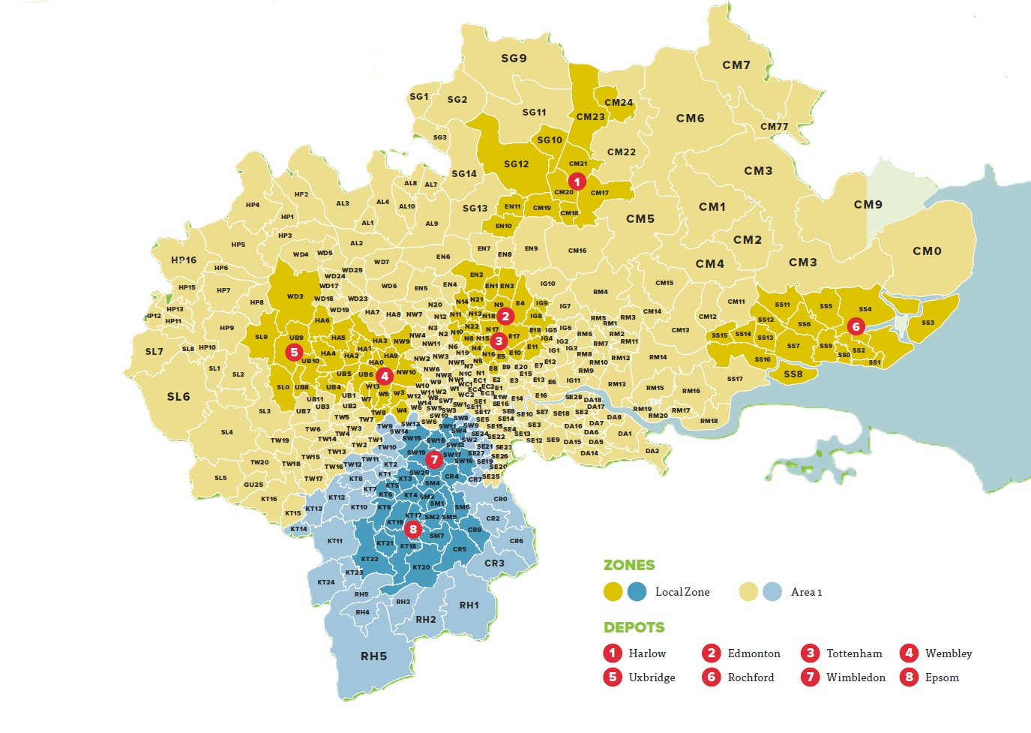
Sortera UK has a total of 8 sites spanning across London and the surrounding areas.

Within this document we will aim to outline the operations of each individual site and figures for the company as a whole whilst sharing our core values and plans for the company going forward.

Edmonton Depot
Gibbs Road, Montagu Industrial Estate, N18 3PU
Permit- EPR/FB3609LQ
TCM- Shane Brown
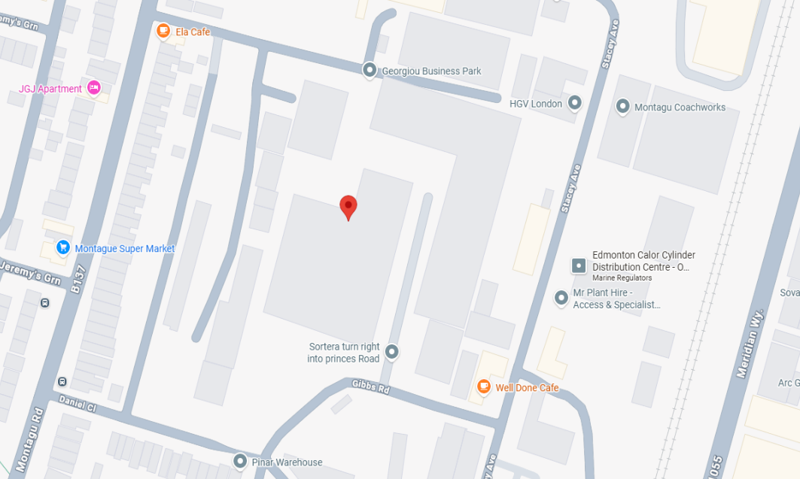

Our Edmonton depot currently has a varied permit and can have an annual throughput of 200,000 Tonnes of waste. The permit authorises a bespoke household, commercial and industrial waste transfer station with treatment. Waste types are limited to non-hazardous and inert only. Treatment may include mechanical and physical sorting, separation, screening, baling, shredding, crushing or compaction.
Operational permitted hours are 24 hours a day, 7 days a week.
Acceptance of Waste
All incoming waste is examined by the dispatching site staff and the vehicle driver at the point of dispatch to ensure that it complies with the Waste Transfer Note for the load. Waste is checked to ensure the load complies with the Waste Transfer Note and the list of permitted wastes. A waste breakdown will be recorded for most tipped waste, and the analysis will be recorded on the company database.
Incoming waste is deposited in the Receiving Area, where it is visible to operators of mobile plant used to introduce the waste to the treatment line.
Any gypsum (plasterboard) found in the incoming waste will be removed by the mobile plant and placed in a separate container.
Water dust suppression will be active during tipping.
If any unauthorised waste or contaminated waste is discovered, it will be moved to the quarantine area and removed from the Site at the earliest opportunity.

Site Plan- Permission Number 17/00555/FUL

Treatment Of Waste
Primary waste treatment is undertaken in Buildings A and B (as shown on site plan Above). The treatment lines normally consist of- Course shredder to ensure that the waste is of a manageable size. Water wash (only on the Lights line in building B) to facilitate separation operations. Magnet separator to remove ferrous metals. Trommel to remove soil and stones. Picking stations to remove wood, metals, and detritus manually (except semi-automatic line). Air separators to separate residual waste into heavy (hardcore) and light (paper, plastic, and card) components.
Wood treatment line- Course shredder to ensure the wood is of a manageable size. Magnet separator to remove ferrous metals. Trommel fines are assessed for their composition. Depending on their composition, the trommel fines may be sent to landfill sites for engineering activities at the landfill; or taken to a site with fines processing equipment for further processing.
The output of the treatment lines is segregated products in bays and containers, ready to be dispatched for re-use/recycling. These are removed from the Site in bulk haulage lorries.
Traffic Management & Onsite Movements
All drivers using the site are to abide by the speed limit and site rules, these are displayed on the entrance to the site.
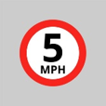
Material is brought to the site in vehicles that are covered (sheeted) to prevent the escape of waste. The site has three access roadways; these are maintained clear at all times so site traffic can safely enter and leave the site by a number of routes. Within the site there are three full-length weighbridges which can be used to store vehicles and plant in an emergency to ensure the entrance way is maintained clear for emergency services.
Wimbledon Depot 1
6 Weir Road, Wimbledon, SW19 8UG
Permit- EPR/JB3735RX
TCM- Joshua Bloomfield
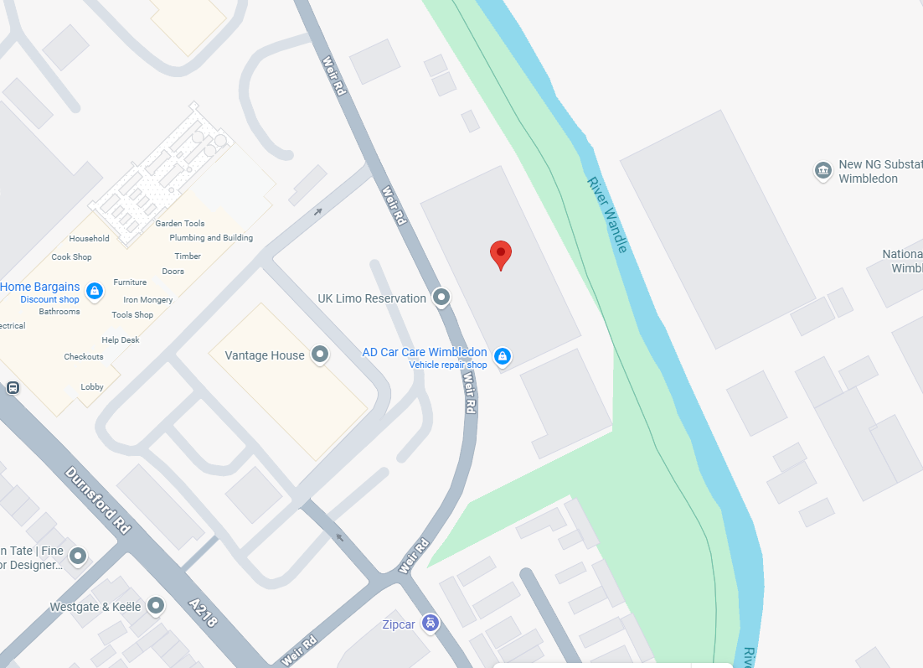
Operational permitted hours are Mon-Fri
Our Wimbledon Depot 1 currently has a varied permit and will allow an annual throughput of 150,000 tonnes of waste. The site operations involve treatment and processing of inert and non-hazardous waste streams for onward recovery. Treatment includes manual sorting, separation, screening, baling, shredding, crushing or compaction of waste. The typical operation of the site will consist of the incoming wastes being processed and treated (physio-chemical treatment by mechanical and manual sorting). No waste will be treated, bulked or transferred outside of the main building.
Acceptance of Waste
Waste entering the site is visually inspected at the site offices and associated duty of care paperwork checked; including details of the waste carrier registration, completion of signatures and dates. Drivers are instructed by staff where to discharge the contents of the delivery. All wastes deposited at the site will be within the main waste transfer building. Wastes are continuously visually inspected by personnel working within the operational areas during the waste processing. If it is noticed that loads contain non-conforming wastes before unloading takes place, the driver is told not to unload and to report to the site offices to receive further instructions from site management. Any wrongly described waste subsequently identified will be recorded in the site diary and advice sought from the TCP and/or Environment Agency, if appropriate.

Site Plan- Permission number 19/P2737

Treatment Of Waste
Wastes are segregated by mechanical and manual means and loaded on to the processing line (trommel and picking station). The treated, segregated and processed waste is moved by mechanical means to the storage and holding areas prior to being reused or recycled off site.

Traffic Management & Onsite Movements
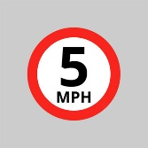
All drivers using the site are to abide by the speed limit and site rules, these are displayed on the entrance to the site.
Skip or “smaller” vehicle drivers will enter the site using the left-side gate, all warning lights are to be used. The Yard Manager or assistant will be available to direct as necessary. Usually, vehicles will be reversed into the holding area, there is space for two vehicles. All vehicles are to be weighed on the Weighbridge prior to completing their tip. When available the vehicle can then be reversed into the main shed and the tipping area. Where possible drivers will remain in their vehicles and tip the load using their remote-control system. If drivers are using an older vehicle it will need to be carried out externally.
If driver the needs to exit the vehicle, correct PPE must be worn, this includes face mask (inside the shed), high visibility clothing, protective footwear and helmets (if necessary). When exiting the vehicle cab, drivers must check for moving plant and ensure they gain eye contact with the plant operatives prior to moving around the vehicle. The load can then be tipped, once the load is tipped, the vehicle is to be moved forward checking the skip or container is empty.. Once complete vehicles are able to leave the transfer station yard using the right gate (from the front), this is located next to the entrance gate. Care is to be taken to avoid pedestrians and moving plant when leaving the yard area.
Depending on the vehicle requiring access and the current working conditions at the time, the Yard Manager may decide to alter the access and egress gates to ensure safer movement in the yard. This will be communicated via the two radios and to the drivers in the holding area, this will ensure they are fully aware of the changes being made. Can be easier to reverse larger vehicles into the yard via the right gate (egress gate). All vehicle movement will be controlled by a trained banksman.
There is also a dedicated night shift working from 18:15hrs each night, through till around 06:00hrs the following morning. During this time there will be vehicles operating in the area although this would be reduced compared to daily use due to noise levels and client collection agreements. Larger vehicles would still be loaded throughout this period and external lighting has been installed to provide sufficient lighting.

Wimbledon Depot 2
77 Weir Road, Wimbledon, SW19 8UG
Permit- EPR/LB3303KH
TCM-Joshua Bloomfield
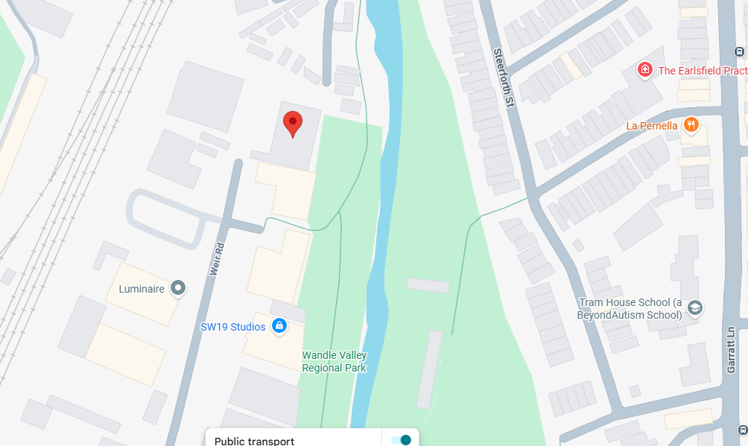

Permitted operational hours Monday-Saturday between 6am-6pm
Wimbledon deport 2 currently has a varied Permit and can have an annual throughput of 150,000 tonnes of waste. The site operations involve treatment and processing of inert and non-hazardous waste streams for onward recovery.
Acceptance Of Waste
All incoming wastes are received and deposited within the main building.
Waste entering the site is visually inspected at the site offices and associated duty of care paperwork checked; including details of the waste carrier registration, completion of signatures and dates. Drivers are instructed by staff where to discharge the contents of the delivery. All wastes deposited at the site will be within the main waste transfer building. Wastes are continuously visually inspected by personnel working within the operational areas during the waste processing. If it is noticed that loads contain non-conforming wastes before unloading takes place, the driver is told not to unload and to report to the site offices to receive further instructions from site management. Any wrongly described waste subsequently identified will be recorded in the site diary and advice sought from the TCP and/or Environment Agency, if appropriate.
Treatment of Waste
Treatment consisting of manual and mechanical sorting (using a grab or similar), screening, shredding, crushing or compaction of waste for disposal, (no more than 50 tonnes per day) or recovery.
The weight of material received and dispatched will be recorded on the weighbridge.
The location of the is on right hand on entry of site. The weighbridge will be maintained in line with the manufacturers specification. This includes inspecting and testing to ensure the correct weight is being recorded to within 0.01 tonnes. Weekly checks will be undertaken to ensure that waste is not accumulating under or in the structure. Any significant accumulated waste will be removed.
Any malfunction or damage to the weighbridges will be recorded in the site diary and repaired immediately.
Site Plan- Permission number 20/P3261
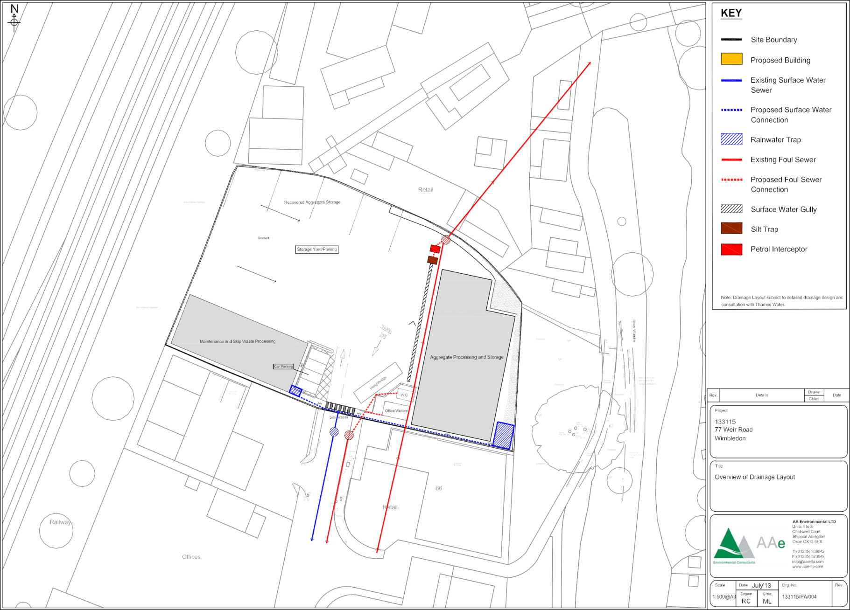

Traffic Management & Onsite Movements
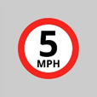
All drivers using the site are to abide by the speed limit and site rules, these are displayed on the entrance to the site.
The site utilises a one-way traffic system for the management of traffic and vehicles.
Drivers and visitors will be controlled by the Yard Management team. Drivers will approach the yard and stop outside the gate on the left-hand side. When space allows a member of the Yard Management team will guide the drivers forward. Drivers will stop on the weighbridge to be weighed and then move forward to allow them to reverse into the tipping area. Vehicles maybe held in this area until space is made available. This will be under the control of the trained Banksman; drivers are not to move without suitable guidance from a trained supervisor.
Drivers will remain in their vehicle wherever possible. Remote control unloading devices are fitted to the newer model vehicles and these should be used. If drivers need to leave the vehicle they are to do so under the guidance and control of the Site Management team. Suitable PPE must also be worn this includes face mask, high visibility clothing, protective footwear and helmets (if necessary). For older vehicles not having the remote system, care is to be taken when exiting the vehicle. PPE is to be worn and drivers are to establish clear eye contact with the Plant operatives prior to leaving the vehicle cab.
The type of vehicles accessing the site will be skip lorries of various sizes, caged lorries and large tipper vehicles. Once called forward by the Yard Management team drivers are to drive their vehicles into the right of the yard. This is currently a holding area and can contain two vehicles. When the tipping area is free, vehicles can then be reversed into the tipping area and carry out their tip. If a large vehicle is being loaded, skip vehicles are only allowed in one at a time. It is also not possible to have more than one collection take place at one time. As the collection location will be dictated by the material being collected, it may be necessary to hold back the skip deliveries until the operation has been completed. This will be communicated to RWM2 and the vehicles being held will then be relocated to the available transfer station.

Wembley Depot
Alperton Lane, Wembley HA0 1EB
Permit- EPR/LP3037WG
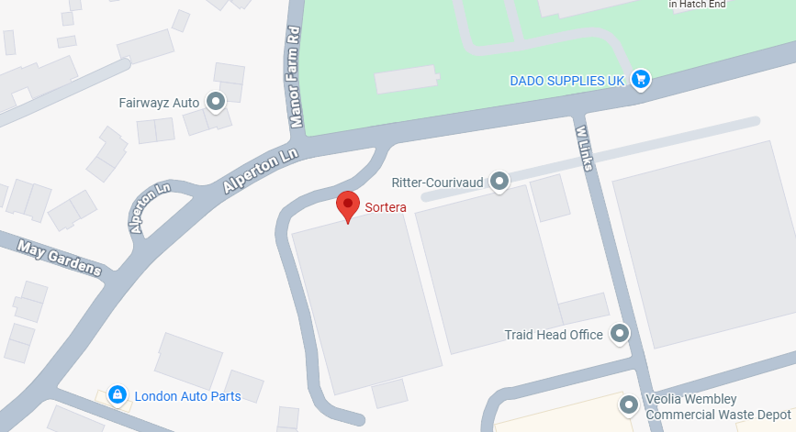
TCM- Billy Bowers

Permitted operational hours- 24 hours a day within the main building (0700-1900 anywhere outside of main building)
Wembley depot has a…. permit and can have an annual throughput of 300,000 of waste. All wastes will be received, stored and processed (non-Haz only) in a building. Non hazardous waste activities taking place inside a building will include; storage of waste in dedicated bays or containers for bulk transfer offsite, manual picking to remove large recyclables, shredding of waste to improve segregation, screening of waste within a trommel to sort items by size, manual segregation on the picking line, baling wrapping of suitable materials as refuse derived fuel (RDF). The permit also allows for the transfer and storage of hazardous waste from the construction and demolition industry only.
Acceptance of waste
All incoming waste is examined by the dispatching site staff and the vehicle driver at the point of dispatch to ensure that it complies with the Waste Transfer Note for the load. All incoming non – hazardous waste is directed to the waste processing building. Tipped waste is checked to ensure the load complies with the Waste Transfer Note and the list of permitted wastes. Separate incoming non-hazardous wastes such as metals, plasterboard and wood, are tipped at the front of their respective bays. The material is inspected to ensure that it is not contaminated. Any contamination is removed either manually or mechanically before the material is pushed up into the bay.
Mixed incoming non-hazardous waste is deposited in the appropriate heavy or light Receiving Area where it is clearly visible to operators of mobile plant used to introduce the waste to the treatment line. Gypsum (plasterboard), large items of metal and wood, will be removed by the mobile plant and placed in separate bays.
If any unauthorised waste, contaminants or contaminated waste is discovered, it will be moved to a quarantine area and removed from site at the earliest opportunity. If the customer is known, the customer will be advised of the unauthorised item(s) and/or contamination. The site does not have a dedicated quarantine area; should the need arise, one will be immediately created to suit the specific requirements.
The site is also permitted to accept a limited range of hazardous wastes for storage and transfer. Wastes include construction and demolition waste containing asbestos, and other hazardous wastes, including; waste oils, varnishes and paints, solvents, and WEEE waste.
Treatment of Waste
Once weighed and logged at the Weighbridge Office, vehicles carrying non -hazardous waste will be directed to the waste processing building to the appropriate Receiving Area – heavy recycling, or light recycling. Site staff monitor in-coming waste to ensure that it complies with the list of permitted wastes. Once tipping is complete the vehicle will exit the site as quickly as possible, after being weighed (if necessary) and logged out.
Waste will be moved from the receiving area by mechanical means and deposited at the start of the waste treatment line. Wastes will be separated mechanically and manually on the waste treatment lines.
Waste treatment line: Trommel to remove soil and stones; Picking stations to manually remove wood, non-ferrous metals and detritus (residual waste); Magnet separator to remove ferrous metals; and Air separator to separate residual waste into heavy (hard-core) and light (paper, plastic and card) components.

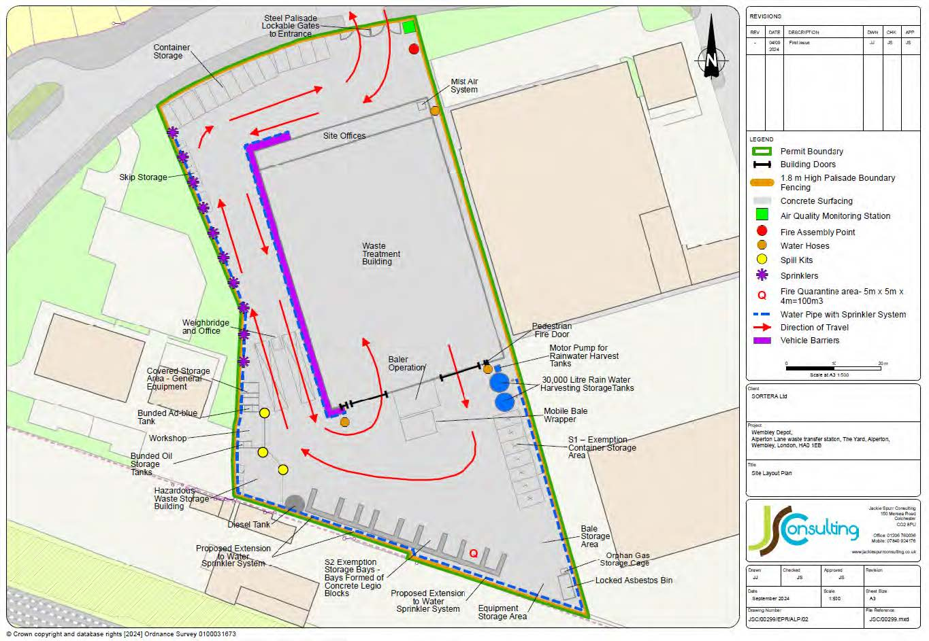
Site Plan- Permissions Number 04/3741

Traffic Management & Onsite Movements

All drivers using the site are to abide by the speed limit and site rules, these are displayed on the entrance to the site.
The yard contains two weighbridges located to the west of the main building, this enables lorries to access the weighbridge when driving forwards whilst entering and leaving the facility.

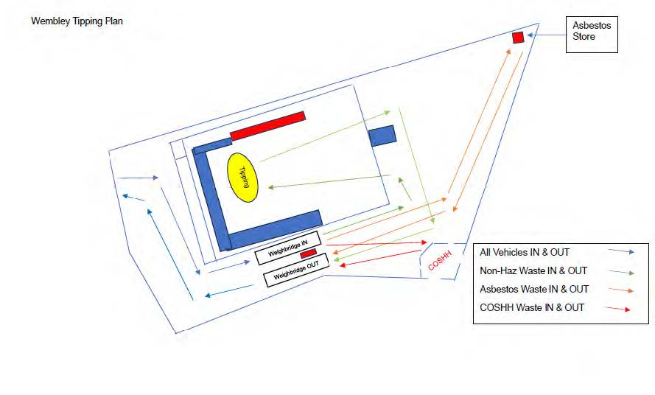

Uxbridge Depot
Skip Lane, Harvil Road, Uxbridge, UB9 6JL
Permit- EPR/CB3709XH
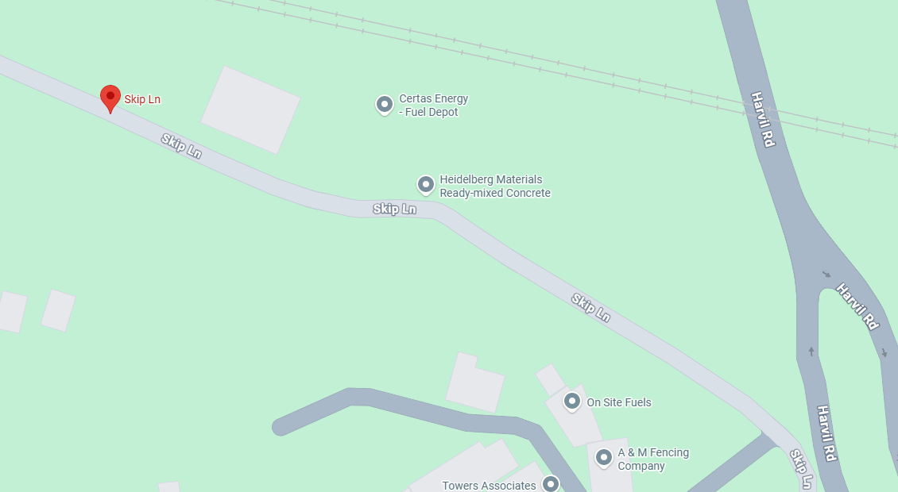
TCM- Billy Bowers

Permitted operational hours 24 hours a day 7 days a week with no restrictions
Our Uxbridge site has a varied permitand can have an annual throughput of 160,000 tonnes of waste at this site. Treatment consisting only of manual sorting, separation, screening, baling, shredding, crushing or compaction of waste into different components for disposal, (no more than50 tonnes per day) or recovery.
Acceptance of waste
The site can only accept non-hazardous waste at this site and will not accept waste in for or type of; powder, sludge, liquid or wet wastes. No more than a total of 50 tonnes of intact and shredded waste vehicle tyres (waste codes 16 01 03 and 19 12 04) shall be stored at the site. Sortera will accept waste directly from customers at this site. Waste may be transferred from other locations or will arrive in/on vehicles under the control of Sortera which have collected the waste from customer sites. If there is any doubt concerning acceptable waste, then the Permit EPR/CB3709XH will be consulted, and no waste will be accepted that is not on the Permit. A copy of the list of permitted wastes from the Permit is maintained in the weighbridge for easy access.
In accordance with the Waste Acceptance Control procedure, loads are inspected at the site of production by the site staff and the vehicle driver, and it is confirmed, so far as these are able, that the load corresponds to the WTN for the load. Once weighed and logged at the Weighbridge Office, vehicles carrying waste will be directed to the appropriate Reception Area – heavy recycling, light recycling, gypsum, or wood storage. During and following tipping the driver will examine the tipped waste and check it complies with the WTN. Site staff also monitor incoming waste to ensure that it complies with the list of permitted wastes.
On collection of a skips the driver shall complete visual and checks for odour on the contents of a skip against the description / waste code on the Waste Transfer Note (WTN). The driver shall record this electronically and take a photo to confirm compliance with the WTN before removing it from the producer’s premises.
In the event that waste does not match the details, description / code on the WTN, the driver shall record this information. If the waste is not acceptable under the Permit the driver will not collect the skip. The producer shall be contacted.
Treatment of waste
Once tipping is complete the vehicle will exit the site as quickly as possible, after being weighed (if necessary) and logged out. Waste will be moved from the receiving area by mechanical means and deposited at the start of the Wastes will be separated mechanically and manually on the waste treatment lines.
The treatment lines normally consist of:
Waste treatment lines (light & heavy) Course shredder (lights line only) to ensure the waste is of a manageable size. Trommel to remove soil and stones. Picking stations to manually remove wood, metals, and detritus. Magnet separator to mechanically remove ferrous metals .Air separators to separate residual waste into heavy (hard-core) and light (paper, plastic, and card) components. RDF Baler and bale wrapper (Light line only) to contain RDF for onward transport.
Wood treatment lines: Course shredder to ensure the wood is at an acceptable size for onward recovery. Magnet separator to remove ferrous metals; and Trommel to remove sawdust and undersized wood.
Fines Cleaner: Waste treatment trommel fines are taken to the fines processing equipment using mobile plant and are placed into the plant which subdivides the fines to produce four outputs: above 10mm heavies; above 10mm lights; below 10mm heavies; and below 10mm lights. These fractions have their dedicated re-use and recycling outlets so are more saleable commodities and increase the sites diversion from landfill.
Plasterboard: Plasterboard (Gypsum - 17 08 02) is received onto site as segregated loads and stored in a designated bay. It is removed from site and transferred off-site for reprocessing in bulk haulage lorries.
Outputs from the treatment lines and the trommel fines processing equipment are segregated products in bays and containers, ready to be dispatched for re-use/recycling. These are removed from site in bulk haulage lorries.

Site Plan- Permission Number 49984/APP/2015/4401

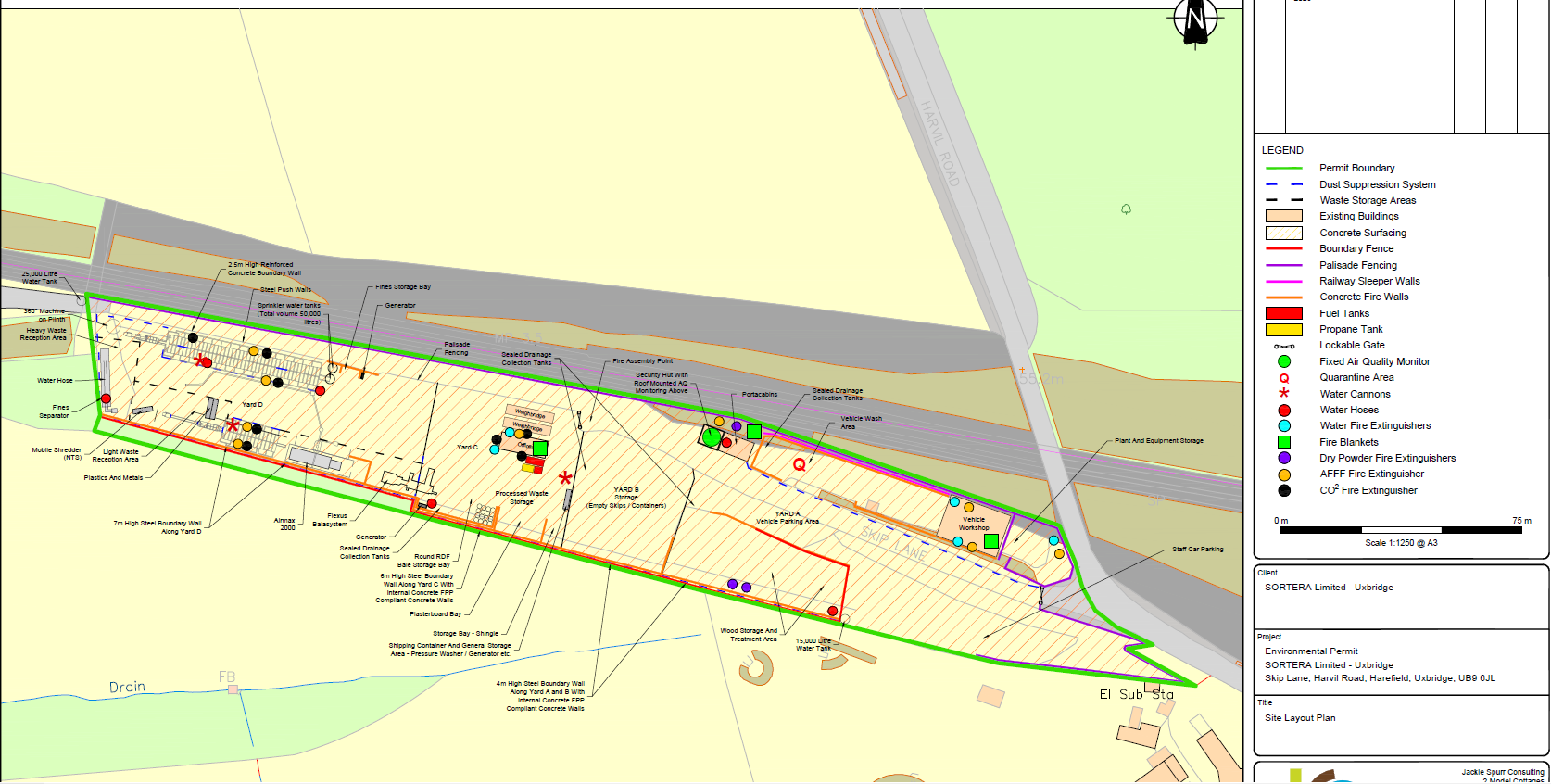

Traffic Management & Onsite Movements
All drivers using the site are to abide by the speed limit and site rules, these are displayed on the entrance to the site.
The site utilises a one-way traffic system for the management of traffic and vehicles.
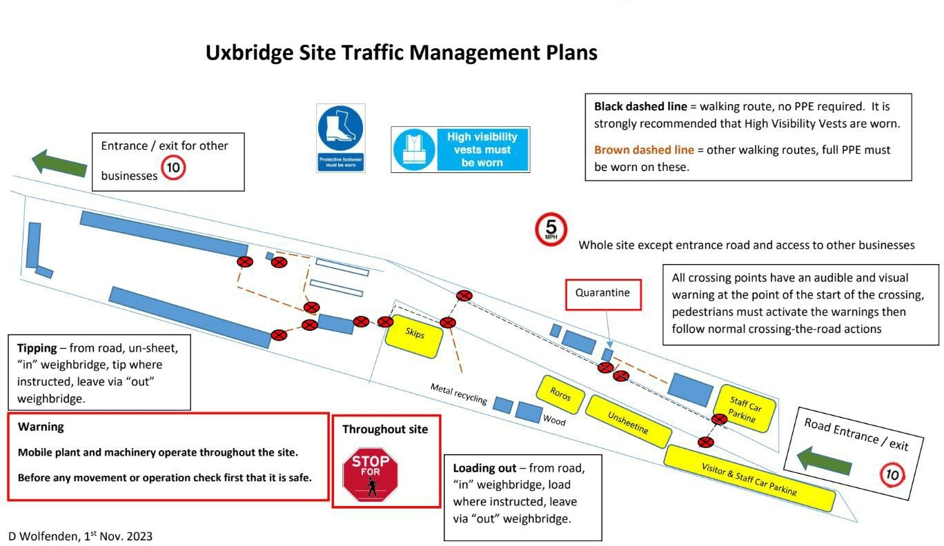

Harlow
Unit 7, River Way, Maple River industrial Estate, Harlow, CM20 2DP
Permit- EPR/CB3339DT
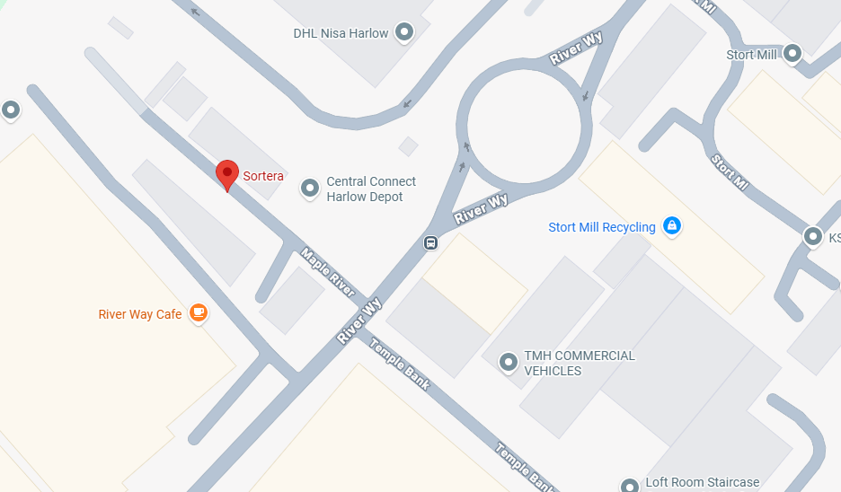
TCM- Shane Brown

Permitted operational hours- 24 hours seven days a week
Our Harlow site has a standard permit an permit and can have an annual throughput of up to 75,000 tonnes
Acceptance of waste
During and following tipping the driver will examine the tipped waste and check it complies with the Waste Transfer Note.
Site staff also monitor incoming waste to ensure it complies with the list of permitted wastes.
Once tipping is complete, the vehicle will exit the site as quickly as possible, after being weighed (if necessary) and logged out.
Waste will be moved from the receiving area by mechanical means and deposited at the start of the waste treatment line. Wastes will be separated mechanically and manually on the waste treatment lines.

Treatment of waste
Treatment consisting only of manual sorting, separation, screening, baling, shredding, crushing, or compaction of waste into different components for disposal, (no more than 50 tonnes per day) or recovery.
Treatment consisting only of depollution of waste motor vehicles and sorting separation, grading, baling, shearing, compacting, crushing, or cutting of waste into different components for recovery. No more than 50 tonnes of intact and shredded waste vehicle tyres (waste codes 16 01 03 and 19 12 04) shall be stored at the site.
Wastes shall be stored for no longer than 1 year prior to disposal and 3 years prior to recovery. The maximum quantity of hazardous waste received at the site for disposal shall not exceed 10 tonnes per day. The maximum quantity of hazardous waste stored at the site for disposal shall not exceed 10 tonnes. Lead acid batteries shall be stored in containers with an impermeable, acid resistant base and a lid to prevent ingress of water. All wastes shall be stored and treated on an impermeable surface with sealed drainage system.
Depollution of ELVs shall only take place within a designated building with a sealed drainage system.
The waste treatment line consists of: Water wash to clean and separate the waste in readiness for segregation and separation; Trommel to remove soil and stones; Picking stations to manually remove wood, non-ferrous metals and detritus (wet waste); Magnet separator to remove ferrous metals; and Air separator to separate residual waste into heavy (hard-core) and light (paper, plastic and card) components.
The treatment line's output, including the trommel, is segregated products in bays and containers, ready to be dispatched for re-use/recycling. These are removed from the site in bulk haulage lorries.

Site plan- Permissions Number HW/CC/13/40002
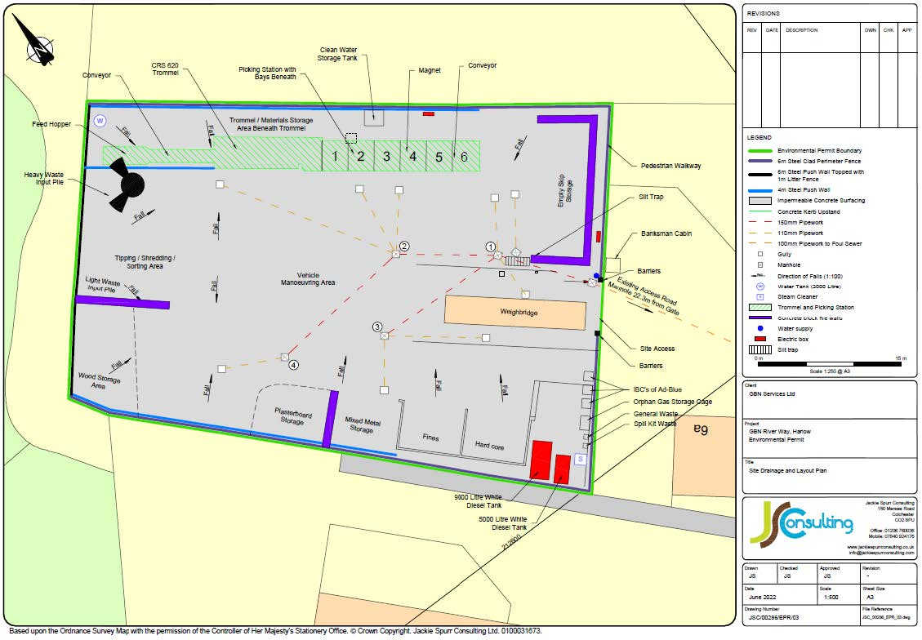

Traffic Management & Onsite Movements
The yard contains a weighbridge located just inside the entrance; this enables lorries to access the site both when driving forward and reversing, on both entering and leaving the facility.
Most of the operation will be carried out outdoors. To limit any possibility of wind-borne nuisance, the site has dust suppression facilities at the entrances and at strategic locations within the yard.
To control dust mud and debris spreading in the yard all lorries that are not conveying enclosed containers will be sheeted and whilst material loading is taking place manual damping will take place to minimise dust.
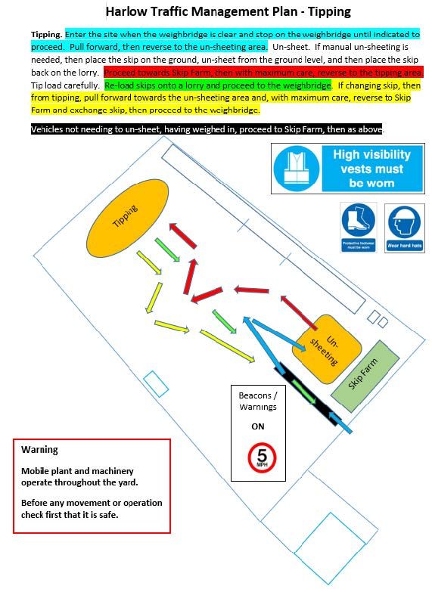

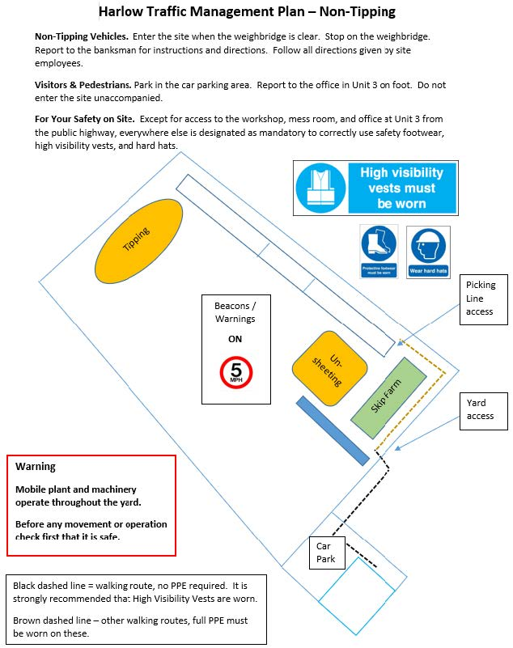

Tottenham
100A Markfield Road, London, N15 4QF
Permit- EPR/AP3695SX
TCM- Liam Clement-Smith
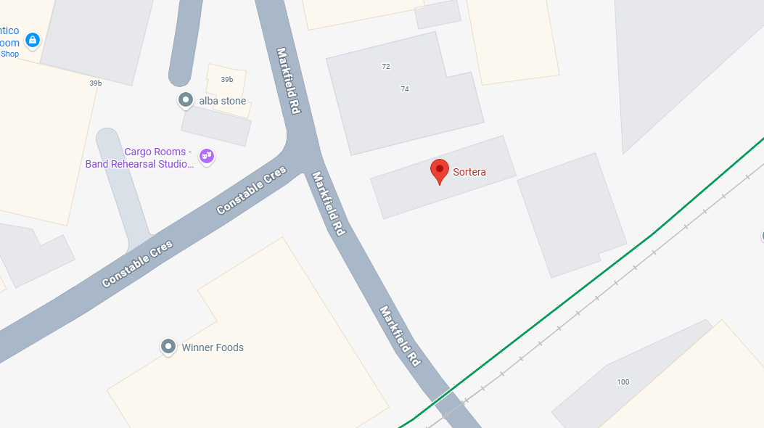

Permitted operational hours- Monday- Friday 0700-1830 Saturday 0700-1400
Our Tottenham depot has a…. permit and can have an annual input of 24,000 Tonnes of waste. Physical treatment including manual sorting/separation, screening, shredding, baling and wrapping of non-hazardous waste for recovery.

Acceptance of Waste
All incoming waste is examined by the dispatching site staff and the vehicle driver at the point of dispatch to ensure that it complies with the Waste Transfer Note for the load. Tipped waste is checked to ensure the load complies with the Waste Transfer Note and the list of permitted wastes. Separate incoming wastes such as, soils, concrete, hardcore, and bituminous wastes are tipped at the front of their respective bays or stockpiles. The material is inspected to ensure that it is not contaminated. Any contamination is removed manually before the material is pushed up into the bay or stockpile. Mixed incoming waste is deposited in the Receiving Area where it is clearly visible to operators of mobile plant used to introduce the waste to the treatment process. Large pieces of concrete and any contrary waste will be removed by the mobile plant and placed in separate bays / stockpiles or containers.
If any unauthorised waste, contaminants or contaminated waste is discovered, it will be moved to a quarantine area / contrary waste container and removed from site at the earliest opportunity. If the customer is known, the customer will be advised of the unauthorised item(s) and/or contamination.

The site does not have a dedicated quarantine area; should the need arise one will be immediately created to suit the specific requirements.
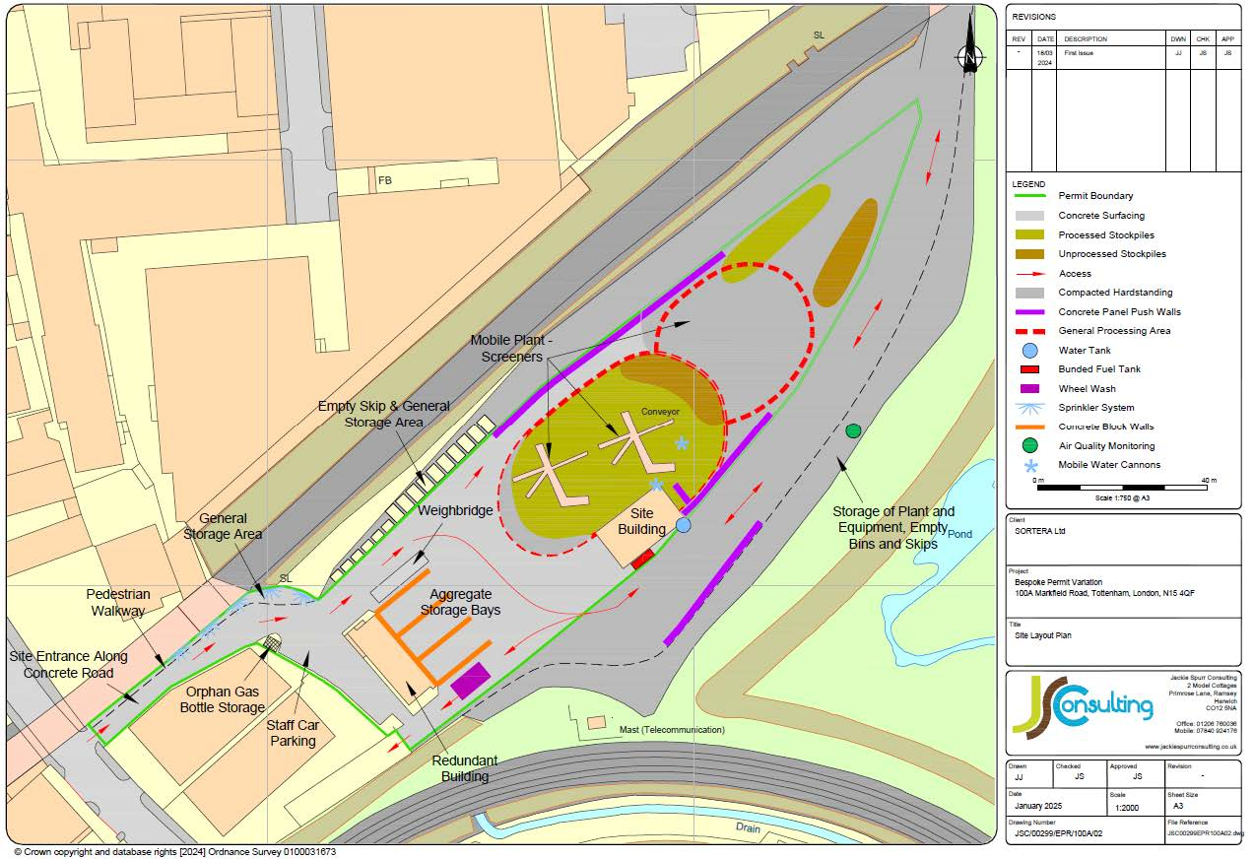
Site Plan- Permission Number HGY/1992/0112

Treatment of Waste
Tipped waste is checked to ensure the load complies with the Waste Transfer Note and the list of permitted wastes. If any unauthorised waste, contaminants or contaminated waste is discovered, it will be moved to a quarantine area / contrary waste container and removed from site at the earliest opportunity. If the customer is known, the customer will be advised of the unauthorised item(s) and/or contamination.
The site does not have a dedicated quarantine area; should the need arise one will be immediately created to suit the specific requirements.
From the receiving area waste only waste close to the processing line input hopper is taken. Waste that is further away is “pushed-up” by mechanical means, In this way the ‘oldest’ waste is treated first, the ‘newest’ waste is pushed into place to create room for more incoming waste. This ensures that all received waste is treated in turn.
Site operatives also undertake manual picking to remove contrary waste such as small pieces of wood, metal, plastic, etc. All segregated wastes are forwarded to other sites for re-use, recycling or recovery operations.

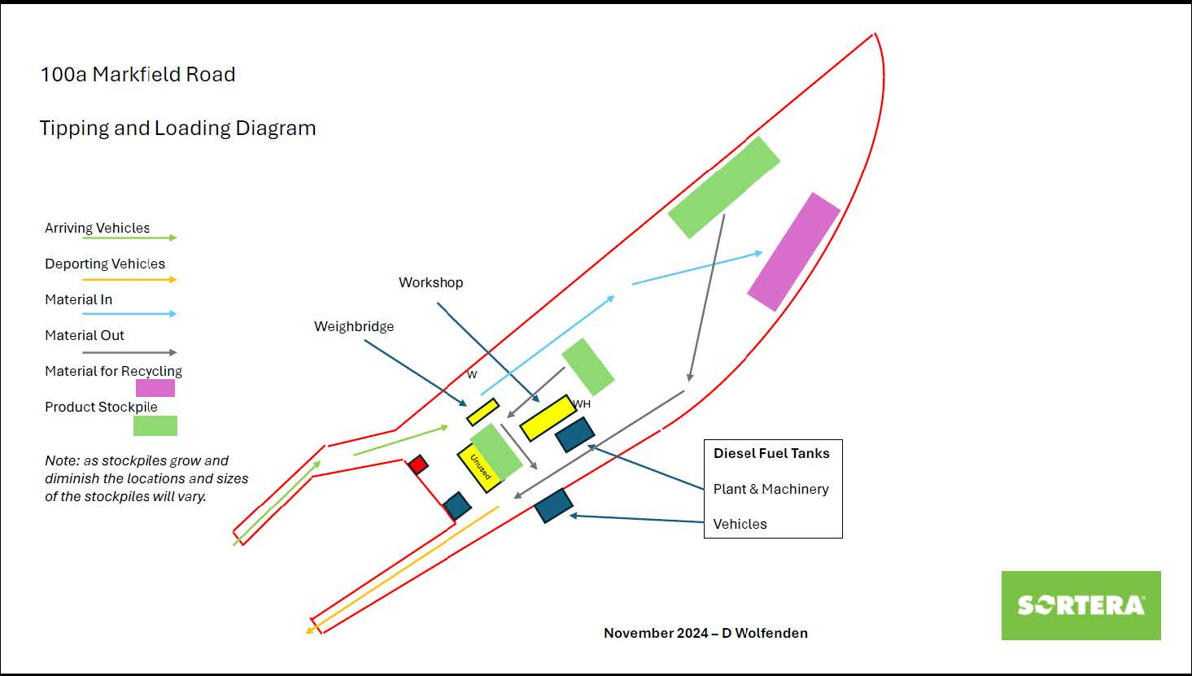
Traffic Management & Onsite movements
The yard contains a weighbridge located alongside the access road, this enables lorries to access the site both when driving forwards and reversing, on both entering and leaving the facility.
Once tipping is complete the vehicle will exit the site as quickly as possible, after being weighed (if necessary) and logged out.
Lorries and lorry trailers not conveying enclosed containers will be sheeted to prevent detritus and dust spreading.

Rochford Depot
Welton Way, Purdeys Industrial Estate, Rochford, SS4 1LA
Permit- EPR/CB3132RU
TCM- Liam Clement-Smith
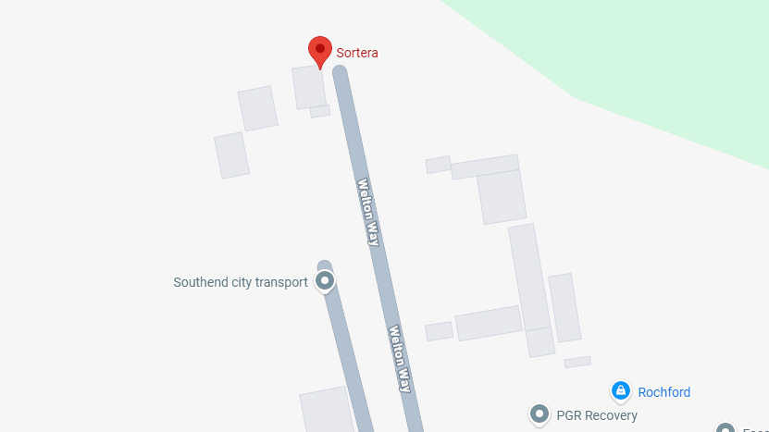

Permitted operational hours- Monday-Friday 0600-1800 Saturday 0600-1200 No operating Sundays or bank holidays
Our Rochford depot has a varied permit that allows an annual throughput of 120,000 Tonnes of waste. Treatment of manual sorting, separation, screening, baling, crushing or compaction of non-hazardous or inert waste into different components for disposal, (no more than 50 tonnes per day) or recovery.
Acceptance of waste
All incoming waste is examined by the dispatching site staff and the vehicle driver at the point of dispatch to ensure that it complies with the Waste Transfer Note for the load. Tipped waste is checked to ensure the load complies with the Waste Transfer Note and the list of permitted wastes (Available on the permit) Incoming waste is deposited in the relevant Receiving Area, where it is clearly visible to operators of mobile plant used to introduce the waste to the treatment line. The mobile plant will remove gypsum (plasterboard) and place it in a separate bay. If any unauthorised waste, contaminants, or contaminated waste is discovered, it will be moved to a quarantine area and removed from the site at the earliest opportunity. The site does not have a dedicated quarantine area for incoming wastes; should the need arise, one will be immediately created to suit the specific requirements; this may be either a bay to contain the unauthorised waste, or the unauthorised waste may remain in the container in which it arrived and be marked as quarantined.

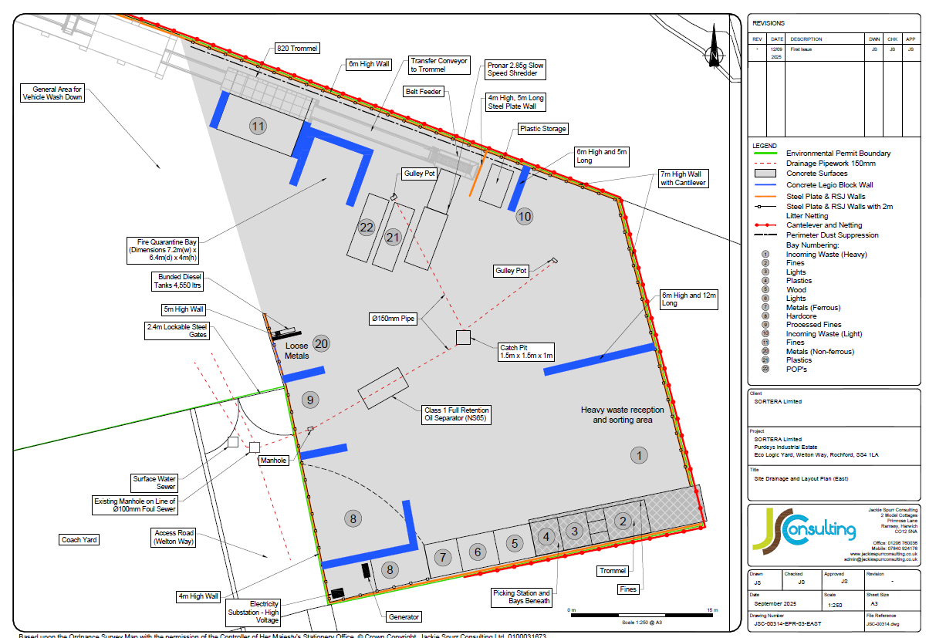
Site plan- Permission Number 90/00205/COU

Treatment of waste

Traffic Management and onsite movements

Treatment of waste
Once tipping is complete, the vehicle will exit the site as quickly as possible after being weighed (if necessary) and logged out. Waste will be moved from the receiving area by mechanical means and deposited at the start of the appropriate waste treatment line; during this process, a course separation (mechanical and manual) will remove large items directly to appropriate storage. Wastes will be separated on the treatment lines by mechanical and manual means. The treatment lines normally consist of the following:
- Trommel to remove soil and stones;
- Air separators to separate light (paper, plastic and card) components;
- Picking stations to remove wood, non-ferrous metals, card and detritus manually;
- Magnet separator to remove ferrous metals;
Depending on the nature of the waste, a mobile shredder may be utilised at the start of the
line to ensure that the waste is of a treatable size. The output of the treatment lines is segregated products in bays and containers, ready to be dispatched for re-use/recycling. These are removed from the site in bulk haulage lorries.

Traffic management & onsite movements
The yard contains a site office block, a workshop complex, staff mess rooms, and toilets. The weighbridge is located within the yard near the site office; this enables lorries to access the site both when driving forwards and reversing, entering and leaving the facility.
All drivers using the site are to abide by the speed limit and site rules, these are displayed on the entrance to the site.
Drivers will stop on the weighbridge to be weighed and then move forward to allow them to reverse into the tipping area. Vehicles maybe held in this area until space is made available. This will be under the control of the trained Banksman; drivers are not to move without suitable guidance from a trained supervisor.
Lorries and lorry trailers not conveying enclosed containers will be sheeted to prevent detritus and dust spreading.

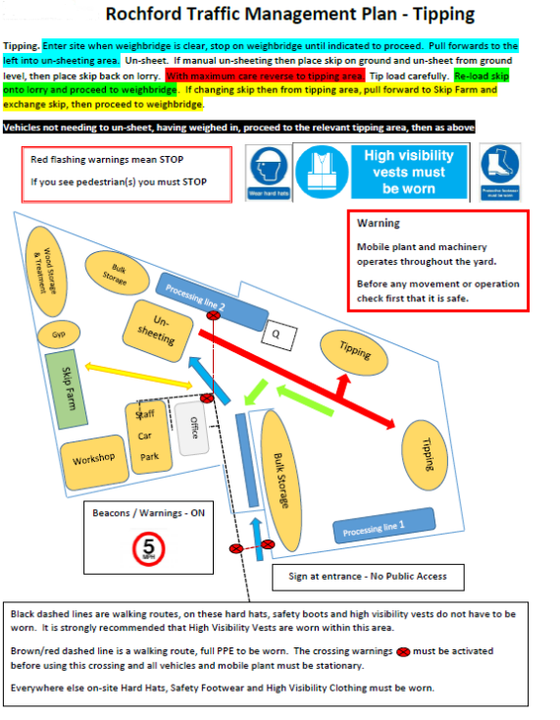

2.) Client Relationships
At Sortera we believe maintaining strong client relationships is essential for long-term success and mutual growth. It begins with clear, honest communication—listening carefully to client needs, setting realistic expectations, and keeping them informed throughout every stage of the process. Consistency and reliability build trust, while responsiveness shows respect for their time and priorities.
Equally important is understanding that each client is unique. Taking the time to tailor your approach, anticipate challenges, and offer proactive solutions demonstrates genuine commitment. When issues arise, addressing them promptly and professionally can strengthen, rather than weaken, the relationship.
Our clients normally fall into two categories producers of waste and receivers.
Producers of waste: These can be companies or individuals looking to have their waste collected. Communication is usually done via telephone or email and our answered by our customer service team. The customer service team will:
- Answer all calls and emails within an appropriate timeframe
- Advise on different waste types and appropriate types of collection (skip, WL, caged vehicle)
- Obtain licences and bay suspensions for skips that need to go on the road
- Provide information on WEEE, Hazardous and non-conforming items
Receivers of outgoing materials: Companies that we have booked as carriers or end destinations for our waste one we have processed such as plastics and wood. Most of the collections of waste are arranged by the depot manager for each site usually via email or phone. Both side of this communication will require certain documentation form each other.
The end destination will require us to complete a WTN or an annual waste transfer note and a weighbridge ticket.
We would before be using the company require a copy of their permit, licences and insurance to ensure that we a using a compliant company and adhering to the waste hierarchy.

3.) Impacts & Risks
Health & safety risks
The waste industry is one of the most at risk industries (second only to agriculture) in terms of health and safety having one of the highest fatal injuries in the UK being roughly 8-10 times higher than an all-industry average. So, it is vital that Sortera takes the risks of the work we are doing into account.
We as a company manage health and safety risks by
- Employment of a third party health and safety consultant (Stallard Kane) who visit sites on a monthly basis to pick up on any hazards and produces a monthly report for this for us to work through any outstanding actions. They will also audit us on a yearly basis.
- Compliance team dedicated to ensuring that the company is compliant with all current legislation regarding the safety of workers. The team also produce and maintain risk assessments, safe working practices, toolbox talks documentation all aimed at communicating the risks to all employees and giving training where necessary.
- Extensive training given to all to staff that is relevant for their role
- First aid and fire marshal trained staff at every depot
- Robust policies that are communicated to all staff on a regular basis
- Log all accidents, incidents and near misses with our entropy portal which then allows the compliance team to monitor and review any trends that may appear. We can then from this action any that need addressing.
Environmental risks
There are many different kinds of environmental impacts or risks that can effect the business with some being harder to plan for then others. These include; Extreme weather condition, Spillages, Fires, Vermin etc. As a company we monitor and plan for these by;
- Environmental policy which is communicated company wide in order for all employees to up keep this
- Spill kits located at every yard in the event of a major spillage
- Fire risk assessments and prevention plans completed for each depot and are reviewed at regular and appropriate intervals
- Sprinklers to dampen dust in the air to prevent catching alight
- Fire equipment such as extinguishers, blankets, hoses at every depot as appropriate
- Regular visit from third party pest control to monitor and treat as necessary
Quality risks
Quality risks to the business are anything that compromise or damage the quality of the services we are providing. These can lead to loss of reputations, reduction in revenue, disruption to operation management, customer dissatisfaction, failure to meet industry standards. As a company we monitor and plan for these by;
- Customer satisfaction calls; our customer service team have a weekly tasks of calling customers and gathering feedback about the service they have received. This is passed onto management to analysis trends and actions as necessary.
- Complaints policy and procedure which highlights how complaints are to be escalated to minimise and negative feedback where possible.
- Internal audits on quality procedures by the compliance team.
ISO
As a company we hold the ISO 14001(environmental), ISO 9001(Quality) and ISO 45001(health & Safety. The accreditation covers all sites mentioned in this document. These accreditations require us as a company to document and manage a CMS which helps us to uphold and maintain standards.
Climate change
Climate change will affect Sortera as well as many other business within and outside our sector. Planning for this is essential however unpredictable. Building resilience is key to being able to adapt to these changes. This includes looking towards diversifying suppliers which we as a company already have an extensive list of approved suppliers. Sortera has also invested in supreme building infrastructures to combat adverse weather conditions that may be a side effect of climate change. Being able to remain flexible as company is what will help us to remain dependable as we have done when these changes happen.
Aspects & Impacts Register
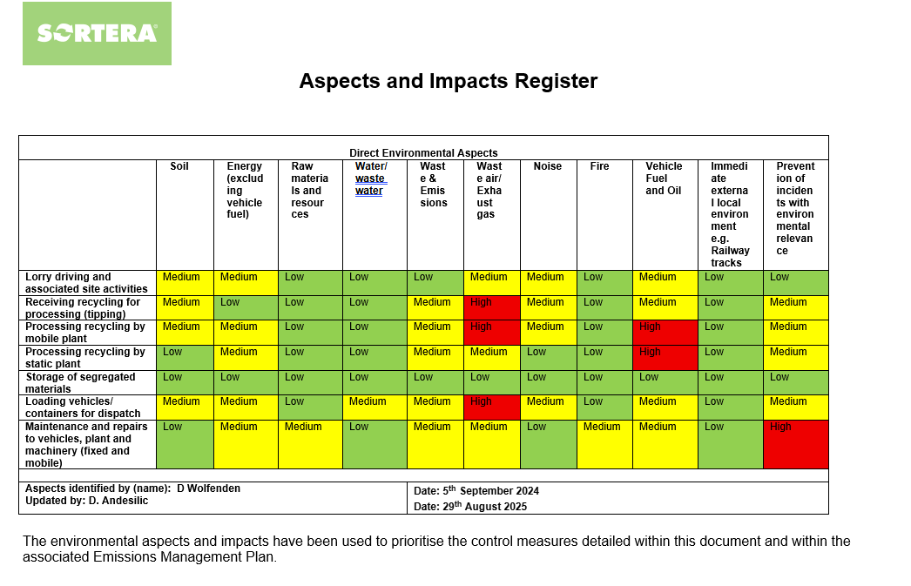
The compliance team maintain and update the aspects and impacts register which allows the business to categories aspects and impacts and monitor these as appropriate.

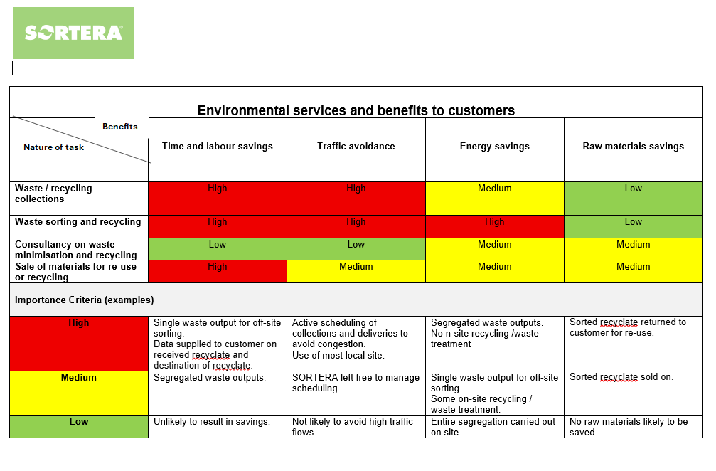

4.) Operational Management
Roles and responsibilities
Sortera defines it’s roles and responsibilities by having a clear organisational structure that is displayed and communicated to the team across the depots. We also define our job titles with robust job descriptions from the first day of employment.

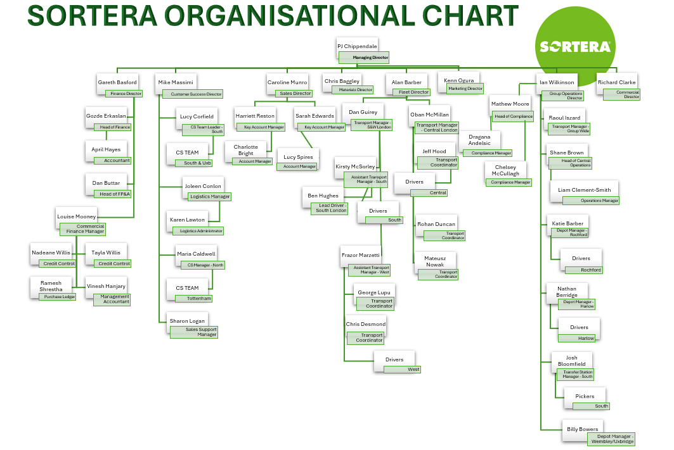

5.) Competence

Duty of care
Sortera has a duty of care for all waste coming in and out of the business and is beholden to The Environmental Act 1990 specifically section 34 (Duty of care). Main requirements of the act are;
- Prevent unauthorised disposal and take all reasonable steps to prevent any treating, keeping or disposal of waste unlawfully
- Prevent escape of waste; Ensure waste is stored appropriately and securely so does not escape your control or permit boundaries
- Use licenced waste carriers only
- Hazardous waste consignments notes
- Complete a waste transfer note for every load of waste with a full written description.
As a company we have processes in place for checking we are using fully licenced waste carriers through our approved supplier onboarding which includes receiving all licences and insurances from any potential carriers.
Security for each site to avoid waste being fly tipped in or around our yards including onsite personnel, alarms, CCTV.
All sites have clear boundaries in place which are known to the team and regularly checked to ensure waste has not surpassed these. Onsite spill kit and emergency procedures in place.
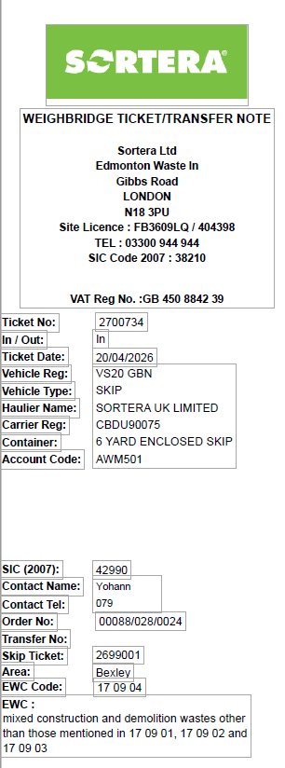
WTN
Sortera uses a digital system called Weighsoft which automatically produces and stores all of our own waste transfer notes.
Waste transfer notes from suppliers coming in are checked to confirm the waste coming in matches the information and EWC code on the WTN and stored at a depot level for the minimum requirement of two years.

Operations team
Each depot manager is in charge of managing for their site; Maintenance of plant and machinery (including refreshing of fleet when necessary), Operating within capacity of their permit in terms of waste on site and annual tonnage, Control of waste on site and waste generated by ourselves, reporting of waste. While these are all big tasks for a deport manager to take on there is assistance provided to aid in gathering the information or controls needed to manage this.
- Weekly operational team meetings which include all 8 deport managers, operations director, compliance team and transport managers. This allows sharing of information between sites and solutions to be found together for example; if one site is nearing its waste capacity can we have waste taken to another deport that is not so busy so that we remain compliant to our permits and fully operational.
- FBP(financial business partner) assists each depot manager by running and analysing waste reports including the running total for waste in and out so that the depot manager can monitor and adjust workloads appropriately.
- Compliance team audits on waste piles, operating procedures, boundary lines, yard capacity.
- Use of Weighsoft reporting for UpToDate figures for all waste- our system allows you to pull reports for waste returns, waste in vs waste out, advanced waste analysis etc.
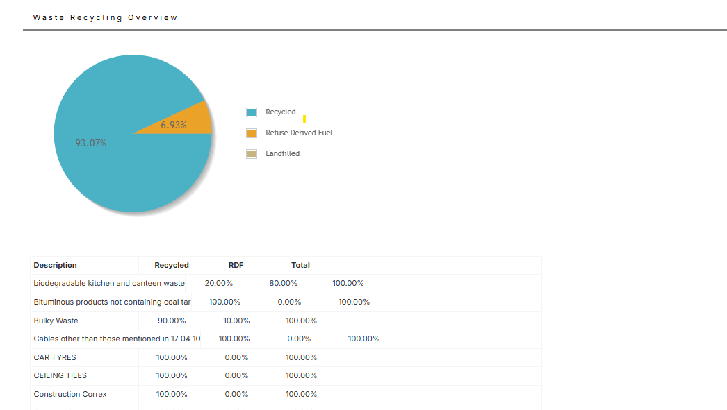
Example reporting

5.) Corrective, Preventative & Improvement Actions
Legal Requirements
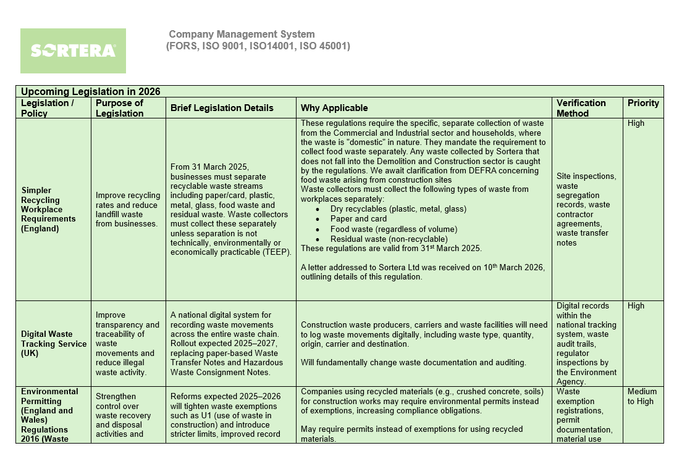
Sortera has both internal and external advice regarding any legislations or regulations that we need to be aware of and comply with. The compliance team is currently 4 members who will keep up to date with any changes regarding waste, health and safety or environmental matters. A tool they use to maintain this is a legal register which is reviewed appropriately.
Sortera holds full and valid insurances for its fleet, plant, fire, public and employee liabilities which are available on our website and request for any customers or suppliers.
Preventative Actions
Plant; All plant machinery has a set maintenance and servicing schedule and allows for defects to be identified and repaired before breakdowns occur lengthening the life span of machinery and minimising repair costs and downtime. All plant operators complete a daily check sheet to report any issues with machinery and confer with their yard manager if anything needs attention. These schedules will be managed by the yard managers.
Vehicles; Like plant machinery our fleet of vehicles have a set maintenance and servicing schedule and drivers are required to fill in a daily diary to report any faults with the vehicle. These will all be managed by the transport managers.
Corrective Actions
Entropy; We use a system called entropy to log all accidents, incidents and near misses. The compliance team then action these and analyse the data for trends. When under review the team determine whether extra control measures, training or other corrective actions are necessary.
Non- conformance log; As part of our ISO accreditations we are required to keep a non conformance log for all quality, environmental or health and safety. The log is managed and maintained by the compliance team who will log and action as appropriate. This tool again allows the team to analyse any reoccurring factors and take action as necessary.
Improvements
Sortera has acquired several London based companies with the newest being ‘Reston Waste’ with official integration of July 2025. With each acquisition the company tries to improve all service levels to the same standard across the board. This has meant taking the best practices from each of its acquisitions and integrating them into the Sortera way.
Improvements made in 2025 include;
- Centralisation of routing of rubbish clearance vehicles to improve jobs completed per day and quality of driver routes
- Expansion and renewal of fleet vehicles
- Unified branding across London acquisitions
- Wider range of benefits and perks available to staff

6.) Competence
It is integral to the business to have competent trained staff in the correct positions throughout the company, it helps us to ensure compliance, reduce safety risks, reduces financial implications, improve culture and retain staff.
TCM
As part of any standard EA permit it is a requirement that the company have a TCM (technically competent persons) on site for 20% of their operational hours. It is a breach of the permit if this is not adhered to which means it is essential that the TCM records time onsite especially if not their normal base of work. We do this usually by completing the site diary.
Sortera currently has 5 TCM’s which is adequate to cover all 8 sites accounting for any periods of absence also. Current TCM trained staff;
- Joshua Bloomfield
- Liam Clement-Smith
- Shane Brown
- Billy bowers
- Chelsey McCullagh
Transport managers
Having trained and competent transport managers is essential to both the running of the business but also the upkeep of the O licence which is essential for any waste management business. The O licence requires vehicle maintenance, qualified personnel (Transport manager level 3) operating centre, traffic commissioner compliance, renewal of licence every 5 years. The employees named on the O licence (OK0211626) are currently
- Alan Barber
- Charlotte Barber
- David Brown
- Joleen Conlon
- Katie Barber
- Oban Mcmillan
- Liam Clement Smith
- Frazor Marzetti
- Daniel Guirey
However, we also have several other employees who are qualified and could cover or replace nominated individuals during periods of absence to ensure business continuity.
Training Matrix
A training matrix is one way we ensure that all of our employees are up to date with any training necessary for their role. We have recently moved onto using the access platform to run this reporting for us which allows the compliance team to more easily assess and manage the training needs of the company.
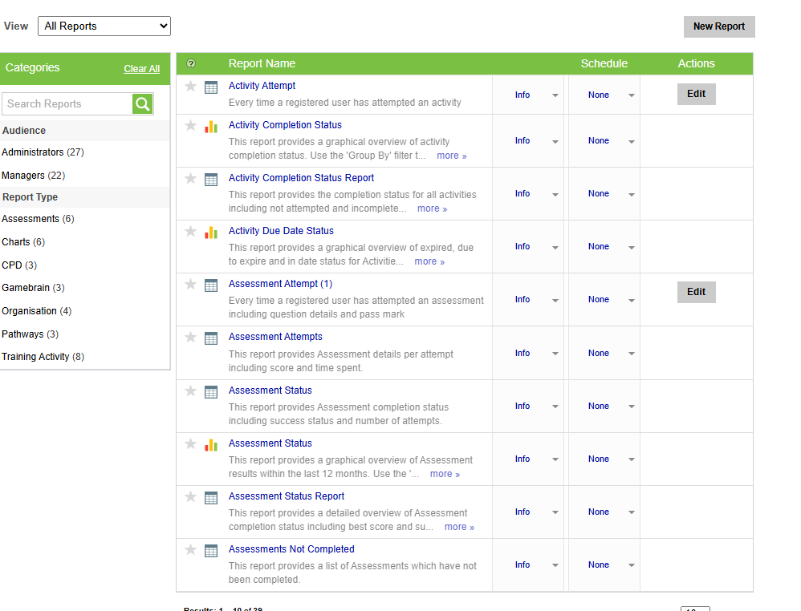

- Performance Review
Performance Summary | Total Tonnes
Total material inputs this period | 536,902.11
Waste used/retained on site this period e.g. for engineering purposes | 0
Waste remaining on site at end of this period (unprocessed) | 8410
Waste remaining on site at end of this period (processed) | 6188
Total waste remaining on site at end of this period | 14,598
Waste sent offsite for reuse/repair this period | 184,532
Waste sent offsite for recycling this period | 237,872
Waste sent offsite for energy recovery this period | 107,984
Qualifying fines | 131, 105
Non-qualifying fines | 0
Materials sent offsite as non-waste this period e.g. end of waste | 0
Waste sent off for disposal (incineration without energy recovery) | 88
Waste sent off for disposal to landfill | 0
Total materials sent off site this period | 530,476

Incoming LOW/EWC Code(s) and Description | Incoming Tonnage | Outgoing LOW/EWC  Recovery/ Disposal  Code and description  (1 only per row) | Outgoing Tonnage | Waste Stream | Destination Treatment Description
Concrete 17.01.01 | 30403.14 | Concrete 17.01.01 | 627.26 | D | Recycle/reuse
Wood (Clean) 17.02.01 | 16,448.20 | Paper & Cardboard Packaging 15.01.01 | 82.86 | D | Recycle/reuse
Mixed Construction 17.09.04 | 432,837.48 | Mixed Packaging 15.01.06 | 246.52 | D | Recycle/reuse
Plastic 17.02.03 | 639.03 | Mixed Construction & Demolition 17.09.04 | 76,095.47 | R | Reprocess
Plasterboard 17.08.02 | 25,896.38 | Other wastes( including mixtures of materials from mechanical treatment) 19.12.12 | 246,765.28 | D | Energy Recovery
Bricks 17.01.02 | 1,664.36 | Paper & Cardboard 19.12.01 | 599.64 | D | Recycle
Paper & Cardboard 20.01.01 | 625.92 | Ferrous Metal 19.12.02 | 10,309.71 | D | Recycle
Glass 17.02.02 | 171.44 | Non Ferrous Metal 19.12.03 | 1,565.35 | D | Recycle
Tiles & Ceramics 17.01.03 | 4.32 | Plastic & Rubber 19.12.04 | 456.48 | D | Energy Recovery
Soil & Stones 17.05.04 | 18050.37 | Wood (not containing dangerous substances) 19.12.07 | 53,888.21 | D | Energy Recovery
Metals 17.04.07 | 2239.55 | Minerals (sand, stones)  19.12.09 | 19,735.73 | D | Recycle/reuse
Textiles 19.12.08 | 117.78 | Combustible waste 19.12.10 | 21,802.05 | D | Reprocess
 |  | Plastics 20.01.39 | 94.20 | D | Recycle/reuse
 |  | Metals 20.01.40 | 51.10 | D | Recycle
 |  | Biodegradable waste 20.02.01 | 263.60 | D | Energy Recovery
 |  | Mixed Municipal 20.03.01 | 606.40 | D | Energy Recovery
 |  | Bulky Waste 20.03.07 | 84.85 | D | Energy Recovery
 |  | Soil And stones 17.05.04 | 2,023.77 | D | Recycle/reuse
 |  | Gypsum Based Construction Materials 17.08.02 | 23,060.72 | D | Recycle/reuse
 |  | Mixed Metals 17.04.07 | 3,048.29 | D | Recycle/reuse

Waste Hierarchy Category | Annual %
Reuse | 9.95
Repair | 0
Recycle | 44.3
Energy Recovery | 20.11
Landfill Cover | 24.41
Disposal | 1.23

