PAS 402 : 2025 Launch

Venue : SCAPE Office,
2nd Floor, East West Building, Tollhouse Hill, Nottingham NG1 5AT

- Meet at 15.00 to 15.30 in Board Room

- 15.30 to 15.40 Mark Robinson Chief Executive of SCAPE welcome

- 15.40 to 16.00 The Launch (Paul Jennings Alex Kay DEFRA)

- 16.00 Group photograph

- 16.00 1o 16.30 Networking

- 16.30 end

- 18.00 meet at hospitality venue to be confirmed

- 19.00 Dinner at Casa Restaurant, 110 Upper Parliament St. NG1 6LF

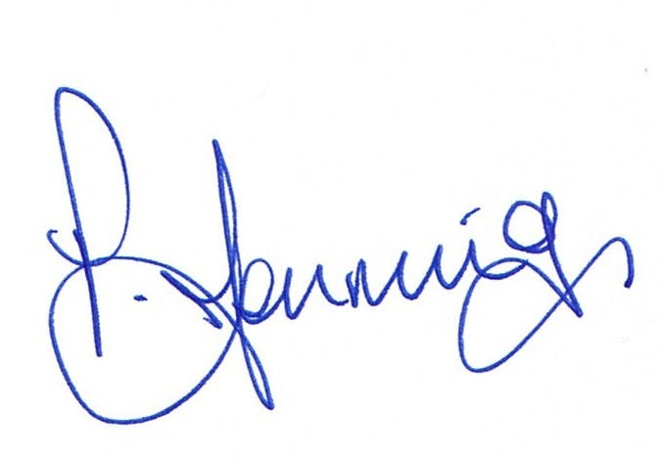

Director

